
PINGHU HUAYE FASTENERS CO.,LTD

PRODUCTS CATALOUGE

FLANGE NUTS
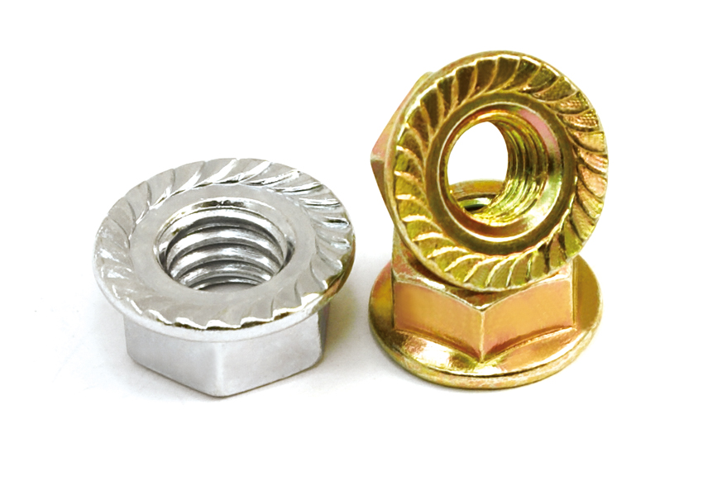
A: CARBON STEEL
B: STAINLESS STEEL
- DIN6923
- JIS1190
- ASTM
- DIN6331
NYLON LOCK NUT
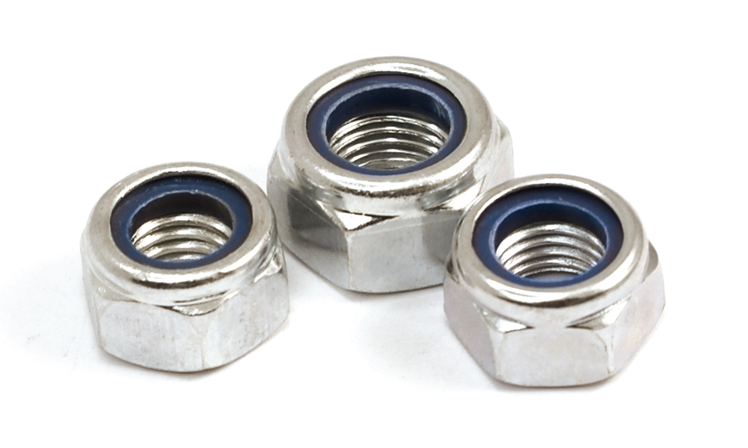
- DIN985
- DIN982
- DIN6926

HEX NUT
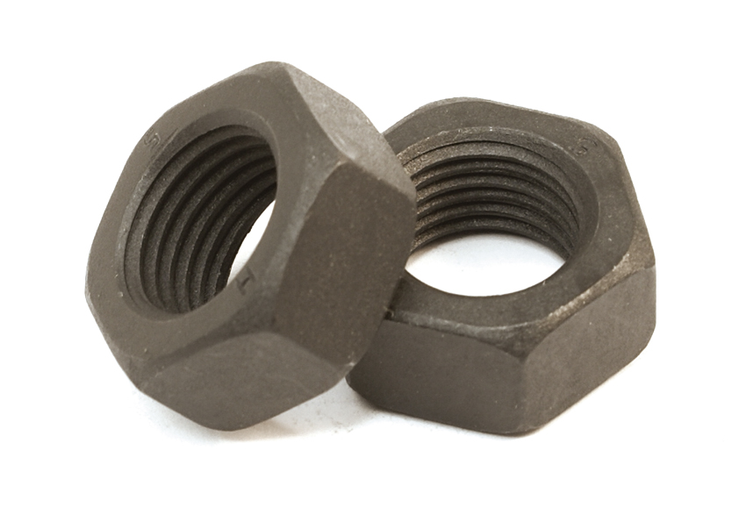
- DIN934
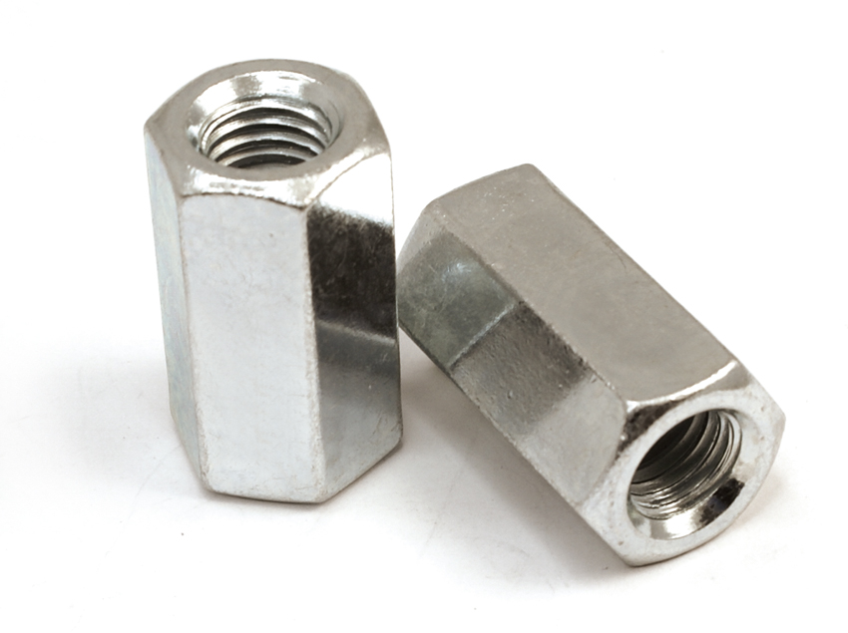
- DIN 6334
CAP NUTS
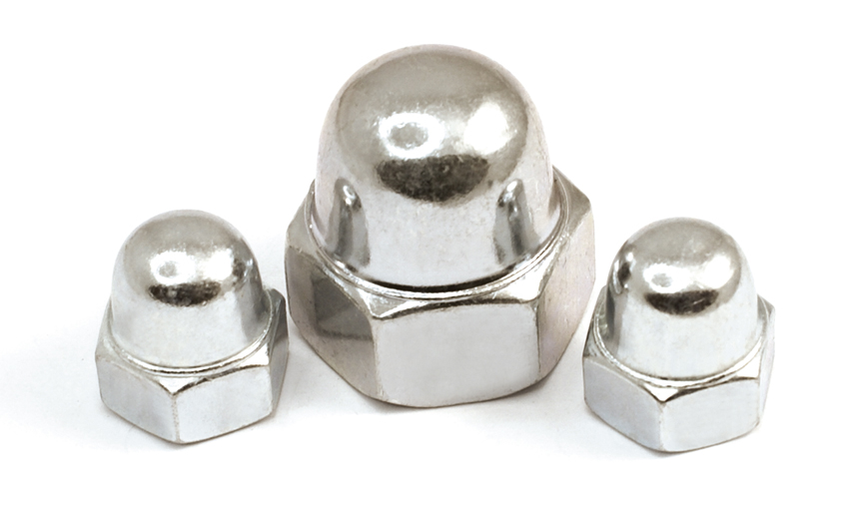
DIN1587

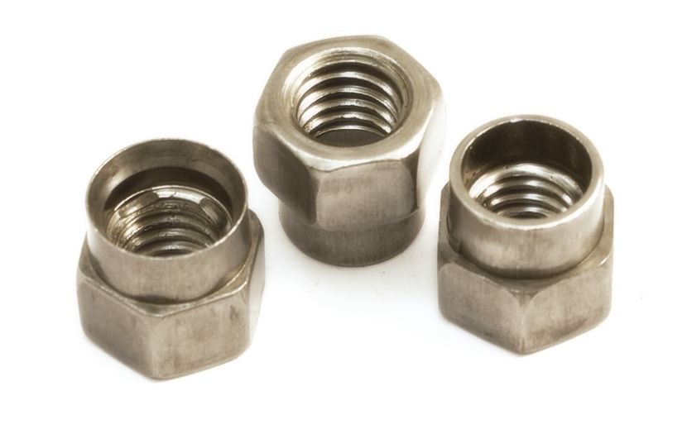
HANGER NUT
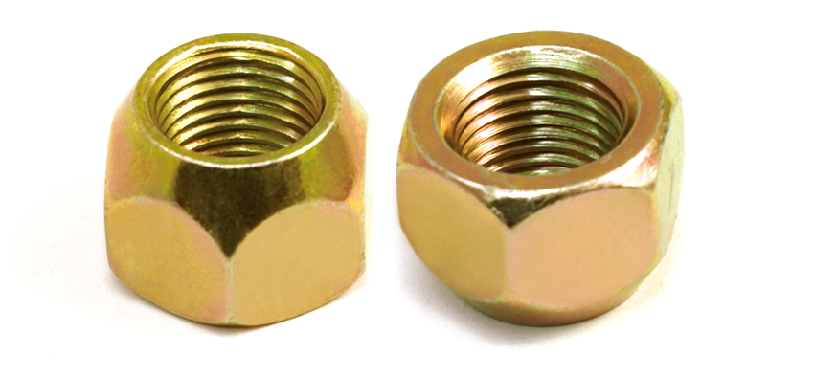
WHEEL NUT

