企业目录 Company Profile

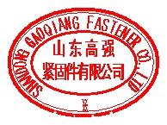
山东高强紧固件有限公司
Shandong Gaoqiang Fastener Co., Ltd.
地址(Add)：山东省诸城市密州街办工业大道1号
Yongtai Industry Estate, Mizhou, Zhucheng,Shandong, China
电话(Tel): 86-536-6550062
传真(Fax): 86-536-6060952 联系人(Contact): George Zhong 钟强 网址(Website)：http://www.jingujian.cc
E-mail: gaoqiang@jingujian.cc

山东高强紧固件有限公司始建于 1975年，为民营企业。现有员工1300多人，其中专业技术人 员128名。生产区占地面积13.45万平方米，主要生产设备600台套，拥有固定资产1.3亿元， 是高强度紧固件专业化生产企业。 公司在同行业率先通过TS16949质量体系认证，坚持“以
质取胜，顾客满意；全员参与，持续改进”的质量方针，以“100%满足顾客要求，并提供优
质服务”的质量承诺回报社会，赢得国内外客户的好评。

Shandong Gaoqiang Fastener Co., Ltd., established in 1975 is a privately-owned enterprise. As a professional fastener manufacturer, the company covers an area of 134,500 m² with
600 production equipments and fixed assets of RMB 130 million and 1300 staffs, including
128 technicians. Having gained the certification of TS16949 in the industry, the company takes “high quality, customers’ satisfaction, all participation, and constant improvement” as
the quality policy and “100% satisfaction and quality service” as the quality commitment.

Company Information / 企业信息
Company Ownership  公司性质 |  | Private Enterprise  民营 | Established Year  成立时间 |  | 1975 |  | Export Experience  是否有出口经验 | Yes
Registered Capital  注册资本 |  | RMB 9.235Million | Total Asset  总资产 |  | RMB 130 Million |  | Turnover of 2008  年销售额 | RMB 0.42 Billion
Total Staff  员工总数 |  | 1300 | R&D Staff  研发人员数 |  | 128 |  | Certification  认证证书 | TS16949(2005)
Key Products  主营产品 |  | High strength bolts of internal combustion engine 内燃机用高强度螺栓
Overseas Branch  是否有海外分支 |  | No |  |  | English Skills(Dept)  熟练掌握英语的员工数 |  | 2(Sale),5(R&D),1(QA/QC)
Design m ould by Themselves  自己设计模具 |  |  |  | Yes |  | Concurrent Engineering capability for OEMs  具备同步开发能力 |  |  | Yes
Development and Manufacture according to Drawings/Sample  能根据图纸/样品来开发 |  |  |  | Yes |  | Develop 3-D Model and Prototype According to Client’s Needs  能根据客户的需求描述设计并生成三维数模 |  |  | Yes
Main Equipments 主要设备 | Production Equipments 生产设备：  CLK6136A NC Lathe/CLK6136 A 数控车床，ZA28-12.5 Thread Rolling Machine/ZA28-12. 5 滚丝机，MT1040A Centerless Grinder/MT1040A 无心磨床，J31-125 Single Point Presser/ J31-125 闭式单点压力机，100TFriction Presser /100T 摩擦压力 机 SY-805-3Mesh-Belt Furnace Production Line/SY-805-3 热处理网带连续炉， 254Cold Forming Machine /254 冷镦机
Main Equipments 主要设备 | Testing Equipments 检测设备：  Universal Testing Machine 万能拉力机 Impact Test Machine 冲击 试 验 机 Metallographic Microscope 大型 工 具 显 微 镜 High Strength Bolt Tester 高强度螺栓智能检测仪 Salt Spray Testing Machine 盐雾试验机 Carbon-sulfur Analyzer 智能碳硫分 析仪 直读真空光谱分析仪 Vacuum spectrometer Coarseness profile Instrument 粗糙度轮廓测量仪

OE Product Information / OE 产品信息
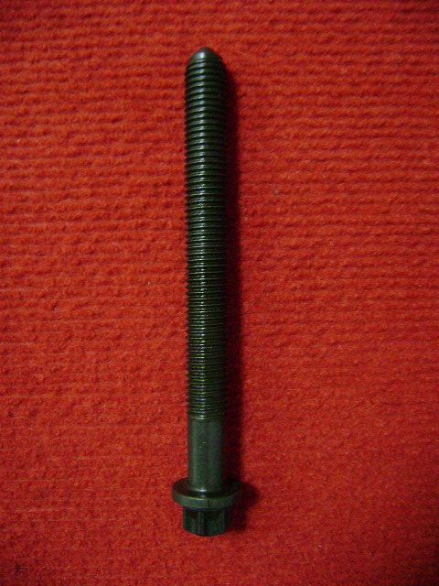 | NO1. |  | Product Information 产品描述 :  Deutz engine cylinder head bolts developed by to substitute imported products for OEM customers 500,000 pieces output Annually Mainly for Diesel Engine of Deutz FAW (Dalian) Co., Ltd.； 道依茨发动机缸盖螺栓，是公司开发的替 代进口产品，结构复 杂、技术含量高，为转角法拧紧，年产 量50万套，主要为道依 茨一汽（大连）柴油机有限公司配套。
Product Name 产品名称 :
Cylinder Head Bolts(1003036-52D)气缸盖螺栓

Typical OE Customer Name 典型OE客户名称 : Deutz(Dalian) Engine Co., Ltd.道依茨一汽（大连）柴 油机有限公司
Designed Capacity 设计产能 : 500,000 Pieces/year
Available Capacity 可用产能 : 80%
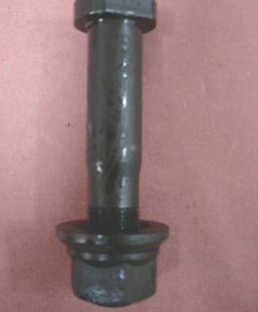 | NO2. |  | Product Information 产品描述 :  Steyr wheel bolts is the leading product in the end of the 1980s , developed by to substitute the imported products for OE customers; The Output is 1.8 million pieces per Year, mainly for Steyr’s heavy vehicles.  斯太尔车轮螺栓，为公司八十年代末开发的替代进口产品，是公  司的主导产品，年产量180万套，主要为斯太尔重型车配套。
Product Name 产品名称 :
WHEEL BOLT 99012340123 车轮螺栓
Typical OE Customer Name 典型OE客户名称 : China National Heavy Duty Truck Group Co., Ltd（中 国重汽集团有限公司）
Designed Capacity 设计产能 : 1,800,000 Pieces/year
Available Capacity 可用产能 : 80%
55 www.gasgoo.com 中国配套供应商 Chinese Automotive OE Suppliers

