OE Product Information / OE 产品信息
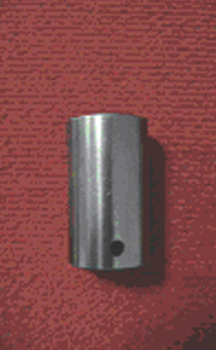 | NO3. |  | Product information  产品描述 :  Product description : Valve tappet for STEYR engine , import substitution products developed at the beginning of  1990s, used alloy steel structure. Product property: complicated structure , high technology , advanced manufacture process, quality stabilization. Application: Used for Valve train of engine.  产品规格：斯太尔发动机气门挺柱，为山东高强九十年代初开发的  替代进口产品，采用合金工具钢性能及优点：结构复杂、技术  含 量高，加工工艺先进，质量稳定可靠。产品用途：用在发动机  配气 机构上。
Product Name 产品名称 :
Valve Tappet（61500050032） 气门挺柱

Typical OE Customer Name 典型OE客户名称 :
Weichai Power Co., Ltd. 潍柴动力股份有限公司
Designed Capacity 设计产能 :
8,000,000 Pieces/year
Available Capacity 可用产能 : 85%
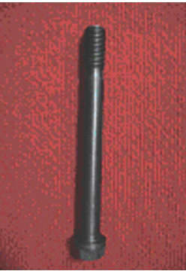 | NO4. |  | Product information  产品描述 :  Product description: Cylinder Head Bolt for STEYR engine, import substitution products developed by themselves at the beginning of 1990s , used alloy steel structure.  Product proper ty : Advanced manufacture process, quality stabilization , tightened with Angle Method, applied to the plastic region. Application: Fastener for cylinder block and cylinder head.  产品规格：斯太尔发动机缸盖螺栓，为我公司九十年代初开发的替  代进口产品，采用合金结构钢制造。性能及优点：工艺先进，性能 稳定可靠；采用转角法拧紧，应用到塑性区.产品用途：紧固发动机 缸体、缸盖。
Product Name 产品名称 :
Cylinder Head Bolt (61500040023) 缸盖螺栓

Typical OE Customer Name 典型OE客户名称 :
Weichai Power Co., Ltd. 潍柴动力股份有限公司
Designed Capacity 设计产能 :
8,000,000 Pieces/year
Available Capacity 可用产能 : 85%
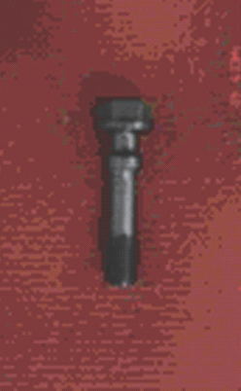 | NO5. |  | Product Information 产品描述 :  Product Specification : Connecting rod bolt for STEYR engine, impor t substitution products developed by themselves at the beginning of 1990s, with alloy steel structure. Capability and Feature: Advanced manufacture process, quality stabilization. Application: Fastener for Connecting Rod.  产品规格：斯太尔发动机连杆螺栓，为山东高强九十年代初开发的替  代  进口产品，采用合金结构钢制造。性能及优点：技术含量高，工艺先 进；转角法拧紧，应用到塑性区。产品用途：用在发动机连杆上。
Product Name 产品名称 : Connecting Rod Bolt
(81500030023) 连杆螺栓

Typical OE Customer Name 典型OE客户名称 :
Weichai Power Co., Ltd. 潍柴动力股份有限公司
Designed Capacity 设计产能 :
4,000,000 Pieces/year
Available Capacity 可用产能 : 82%
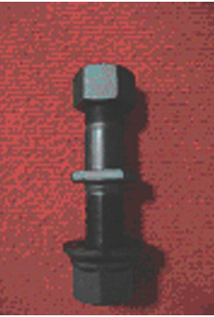 | NO6. |  | Product Information 产品描述 :  Product Specification : Hub bolt for FUHUA axle, with alloy steel structure.  Feature : Advanced manufacture process, capabilit y and quality stabilization. Application: Fastener for rim of 13t or 16t Axle. 产品规 格：富华车桥轮毂螺栓，采用合金结构钢制造。 性能及优点：制造 工艺先进，性能稳定，质量可靠。 产品用途：13吨、16吨车桥紧固 轮辋用。
Product Name 产品名称 :
Hub Bolt（3603/QI） 轮毂螺栓

Typical OE Customer Name 典型OE客户名称 :
GuangDong Fuwa Engineering Manufacturing
Co., Ltd 广东富华工程机械有限公司

Designed Capacity 设计产能 :
10,000,000 Units/year
Available Capacity 可用产能 : 90%
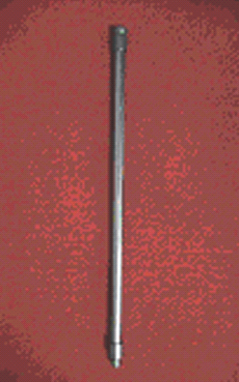 | NO7. |  | Product Information 产品描述 :  Product Specification : Valve lifter for STEYR engine, import substitution products developed by our company at the beginning of  1990s, with advanced structure and high technology.  Feature: Complicated structure, with advanced manufacture process and high resistibility to compression. Application: Used for Valve train of STEYR engine  产品规格：斯太尔发动机气门推杆，为山东高强九十年代初开发的 替代进口产品，产品结构先进，技术含量高。 性能及优点：结构紧 凑，工艺先进，具有较强的抗压性。 产品用途：用在斯太尔发动机配 气机构上。
Product Name 产品名称 :
Valve Lifter(81500050070) 气门推杆

Typical OE Customer Name 典型OE客户名称 :
Weichai Power Co., Ltd. 潍柴动力股份有限公司
Designed Capacity 设计产能 :
4,000,000 Pieces/year
Available Capacity 可用产能 : 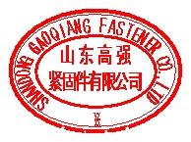80%

Chinese Automotive OE Suppliers 中国配套供应商 www.gasgoo.com 56

